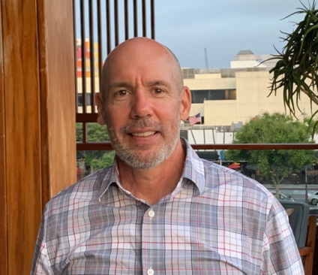
Doug Sullivan RN, CCM.

Prior to working directly as a Certified Case Manager for Medicare Advantage Plans and helping patients transition from inpatient hospital care to HHC and outpatient treatments. My administrative clinical career began with IPA’s and health plans. Initially with Allied Physicians of California and Network Medical Management building up a Utilization Review Dept for that IPA/MSO. Then 8 years in Quality Development and Compliance Oversight for Molina Health Plan. They needed to initiate contracts with the State of California as a MMCP (Medicaid Managed Care Plan). This involved training and preparing all the Molina Staff Model Facilities and the first 5% of all the contracted individual practices for the State audits and oversight. This also led to the co-development of a FSR (facility site review) software application that listed and aligned the State facility site compliance regulations and tracked the status of Molina’s Staff model and contracted practices. Currently all MMCP’s are using a tracking software application to validate compliance.
This administrative and technical background prepared me well with my roles working as a CCM for Great West Health Care that became acquired by Cigna then at first working as a HEDIS Project RN for SCAN then hired as a CCM for Geriatric CM.
Following my career at SCAN I returned to QM and worked for Care First as a Supervisor and DHCS Master Trainer to teach, oversight and managed team of RN’s doing Facility Site and Medical Record reviews on contracted practices with MMCP’s. These experiences prepared me well for helping practices transition to EHR/EMR’s and incorporation of basic knowledge they needed to participate in VBC (Value Based Care). I was re-hired by Network Medical Management as a QI Project Manager. Initially to implement a robust HEDIS and STAR strategy for the several contracted Health Plans and IPS’s then later to develop Clinical Programs to meet STATE and CMS criteria and improve patient outcomes. While working on these programs I learned about the high volume of work that was outsourced overseas, mainly to the Philippines and S. America. My next position was as an independent contractor for a BPO Call Center in Angeles City Philippines and in San Jose Costa Rica. I assisted hiring training and managing clinical staff that worked for USA based Health Plans and MSO’s. This was also about the same time that RPM (Remote Patient Monitoring) was approved as a benefit for MediCare. Upon return to USA, I teamed up with a physician and a few staff to start an RPM and CCM virtual practice. This led to a series of consulting contracts to assist other practices set up their own RPM programs. The basis for all the above has been training, training, training. Managed care, case management utilization management and technology are complicated, but we must trainsition.
I’m currently working as an Clinical Program Advisor and Start Up Consultant.

